**Normpdf with Different Std Deviation**

close all;

pkg load statistics;

x=-5:0.1:5;

y=normpdf(x,0,0.1);

subplot(2,2,1);

plot(x,y);

xlabel('x');

ylabel('pdf');

title('normpdf with mean 0 and std deviation 0.1');

y=normpdf(x,0,0.5);

subplot(2,2,2);

plot(x,y);

xlabel('x');

ylabel('pdf');

title('normpdf with mean 0 and std deviation 0.5');

y=normpdf(x,0,1)

subplot(2,2,3);

plot(x,y);

xlabel('x');

ylabel('pdf');

title('normpdf with mean 0 and std deviation 1');

y=normpdf(x,0,2);

subplot(2,2,4);

plot(x,y);

xlabel('x');

ylabel('pdf');

title('normpdf with mean 0 and std deviation 2');

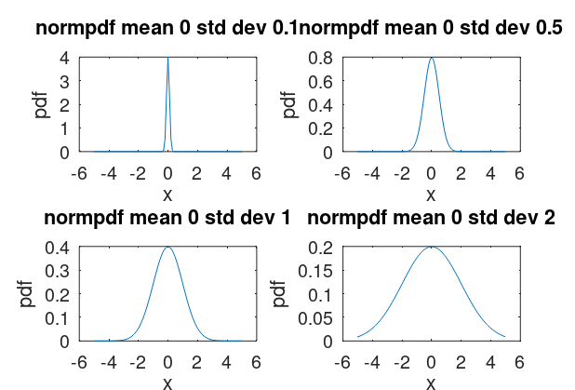

**Normpdf with Different Mean**

close all;

pkg load statistics;

x=-5:0.1:5;

y=normpdf(x,0,1);

subplot(2,2,1);

plot(x,y);

xlabel('x');

ylabel('pdf');

title('normpdf with mean 0 and std deviation 1');

y=normpdf(x,1,1);

subplot(2,2,2);

plot(x,y);

xlabel('x');

ylabel('pdf');

title('normpdf with mean 1 and std deviation 1');

y=normpdf(x,2,1)

subplot(2,2,3);

plot(x,y);

xlabel('x');

ylabel('pdf');

title('normpdf with mean 2 and std deviation 1');

y=normpdf(x,3,1);

subplot(2,2,4);

plot(x,y);

xlabel('x');

ylabel('pdf');

title('normpdf with mean 3 and std deviation 1');

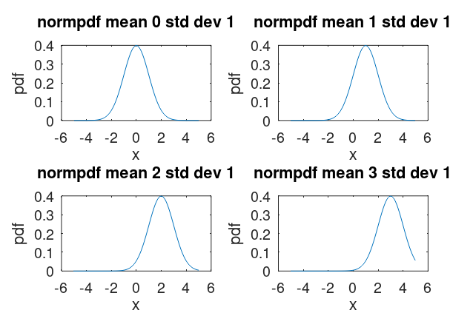

**Unifom Pdf**

close all;

pkg load statistics;

x=-5:0.01:5;

y=unifpdf(x,0,1);

subplot(2,2,1);

plot(x,y);

axis([-5 5 0 1.5]);

xlabel('x');

ylabel('pdf');

title('Unifpdf range 0-1');

y=unifpdf(x,0,2);

subplot(2,2,2);

plot(x,y);

axis([-5 5 0 1.5]);

xlabel('x');

ylabel('pdf');

title('Unifpdf range 0-2');

y=unifpdf(x,0,3);

subplot(2,2,3);

plot(x,y);

axis([-5 5 0 1.5]);

xlabel('x');

ylabel('pdf');

title('Unifpdf range 0-3');

y=unifpdf(x,0,4);

subplot(2,2,4);

plot(x,y);

axis([-5 5 0 1.5]);

xlabel('x');

ylabel('pdf');

title('Unifpdf range 0-4');

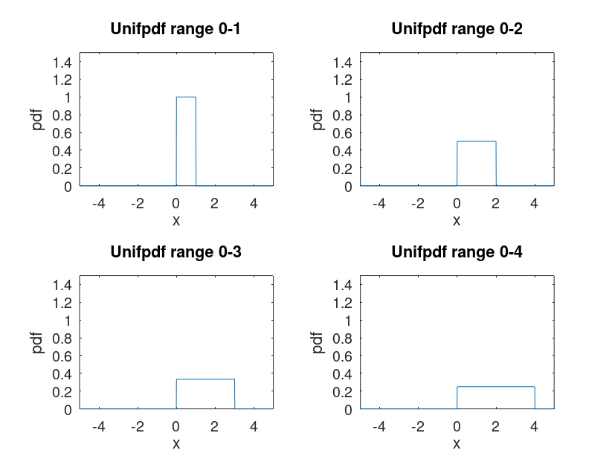

**Poission Pdf**

clc;

pkg load statistics;

x=-5:0.1:5;

y=poisspdf(x,1.5);

subplot(2,2,1)

plot(x,y)

axis([-5 5 0 1.5])

xlabel('x')

ylabel('pdf')

title('poission pdf with lambda 1.5')

x=-5:0.1:5;

y=poisspdf(x,2);

subplot(2,2,2)

plot(x,y)

axis([-5 5 0 1.5])

xlabel('x')

ylabel('pdf')

title('poission pdf with lambda 2')

x=-5:0.1:5;

y=poisspdf(x,2.5);

subplot(2,2,3)

plot(x,y)

axis([-5 5 0 1.5])

xlabel('x')

ylabel('pdf')

title('poission pdf with lambda 2.5')

x=-5:0.1:5;

y=poisspdf(x,3);

subplot(2,2,4)

plot(x,y)

axis([-5 5 0 1.5])

xlabel('x')

ylabel('pdf')

title('poission pdf with lambda 3')

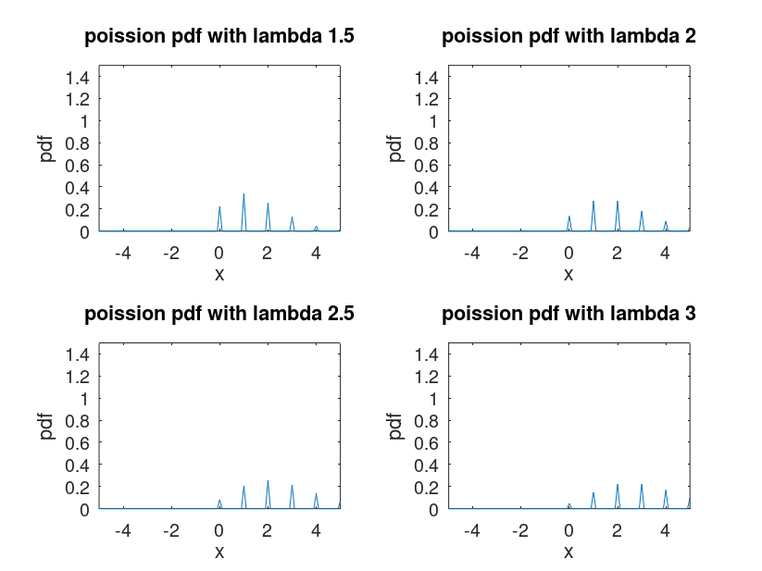

**Exponetial PDF**

clc;

pkg load statistics

x= -5:0.01:5;

y= exppdf (x,0.1)

subplot(2,2,1)

plot (x,y)

xlabel('x')

ylabel('pdf')

title('exppdf mean 0.1')

subplot (2,2,2)

x= -5:0.01:5;

y= exppdf(x,0.5)

plot(x,y)

xlabel ('x')

ylabel ('pdf')

title ('exppdf mean 0.5 ')

subplot (2,2,3)

x= -5:0.01:5

y= exppdf (x,1)

plot (x,y)

xlabel ('x')

ylabel ('pdf')

title (' exppdf mean 1 ')

subplot (2,2,4)

x= -5:0.01:5;

y= exppdf (x,2)

plot(x,y)

xlabel ('x')

ylabel (' pdf')

title (' exppdf mean 2 ')

